Free North Adams!
MASS MoCA Expands Free Admission Program for 01247 residents
North Adams neighbors admitted to galleries free of charge on the 4th day of each month, October 4, 2015 – June 4, 2016
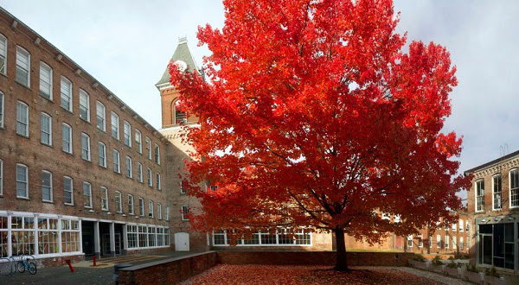
NORTH ADAMS, MASSACHUSETTS — North Adams residents should mark their calendars for the 4th of each month, October 2015 through June 2016. MASS MoCA offers free gallery admission to its North Adams neighbors—those living in the 01247 zip code—beginning this fall, and continuing through spring 2016.

Building on the popularity of a pilot program to offer free admission to North Adams residents one day each month during its non-summer season, this year’s program kicks off on Sunday, October 4, accompanied by free hotdogs following the North Adams Fall Foliage parade.

MASS MoCA has traditionally taken one Saturday every winter to throw open its doors and welcome the crowds in for free. Last year, the museum was approached by several North Adams city councilors who suggested that many residents work on weekends and therefore could not make it to the museum for its annual free day, but would relish the opportunity to access the museum more affordably. The idea of a rotating day of the week throughout the year, with free admission to city residents, was hatched. In the spring of 2015, MASS MoCA saw its attendance during Free North Adams days increase by almost one-third as city families, friends, teachers, and students took advantage of free admission to check out the art museum in their backyard.

This season, Free North Adams kicks off on October 4 with a Free For All event following the city’s annual Fall Foliage parade. Celebrating the 60th year of that storied parade, the museum welcomes all visitors (city residents and beyond) free of charge beginning at 2pm. Free hotdogs (while supplies last!) will be served next to SuttonBeresCuller’s Big Top Grand Stand, a work of circus-like proportion resembling a concession stand, which the museum installed for its Solid Sound Festival this past June.

“One of the highlights of our annual Free Day is watching kids—who visit the museum’s Kidspace several times a year as part of their schooling—come into the museum, leading their parents through the galleries,” notes MASS MoCA deputy director Larry Smallwood. “It’s rewarding for us to find opportunities to see more of that.”

Residents residing within the 01247 zip code (including Clarksburg and Florida, MA) should bring a government-issued ID or a utility bill with current address (and picture ID) when visiting the museum. MASS MoCA's galleries, located at 87 Marshall Street, are open 10am to 6pm every day, with extended evening hours to 7pm on Thursdays through Saturdays, when performing arts events are often featured, through September 7. Beginning September 8, the museum is open from 11am to 5pm every day of the week, except Tuesdays.

Other Free Programs
The annual mid-winter Free Day (which is open to all visitors, not just 01247 residents) is scheduled for January 30 this year. The museum also has a long-term partnership with several libraries in the region, including the North Adams Public Library, through which library users can “check out” a free admission pass to MASS MoCA for up to four visitors.

Admission to Kidspace, the museum’s child-centered gallery and art-making space, is always free, all year long. During the academic year, Kidspace collaborates with the region’s elementary schools to provide arts education programming, bringing thousands of local schoolchildren through the museum for free each year.

About MASS MoCA
MASS MoCA is one of the world's liveliest (and largest) centers for making and enjoying today's most important art, music, dance, theater, film, and video. Hundreds of works of visual and performing art have been created on its 19th-century factory campus during fabrication and rehearsal residencies, making MASS MoCA among the most productive sites in the country for the creation and presentation of new art. More platform than box, MASS MoCA strives to bring to its audiences art experiences that are fresh, engaging, and transformative.

MASS MoCA's galleries are open 11am to 5pm every day except Tuesdays. The Hall Art Foundation’s Anselm Kiefer exhibition is open during museum hours, through November (weather permitting). The Kiefer exhibition reopens for the spring and summer seasons in mid-April. Gallery admission is $18 for adults, $16 for veterans and seniors, $12 for students, $8 for children 6 to 16, and free for children 5 and under. Members are admitted free year-round. For additional information, call 413.662.2111 x1 or visit massmoca.org.

