MASS MoCA Awarded Grant
from The Andrew W. Mellon Foundation
Funds support future artist residencies in the visual and performing arts
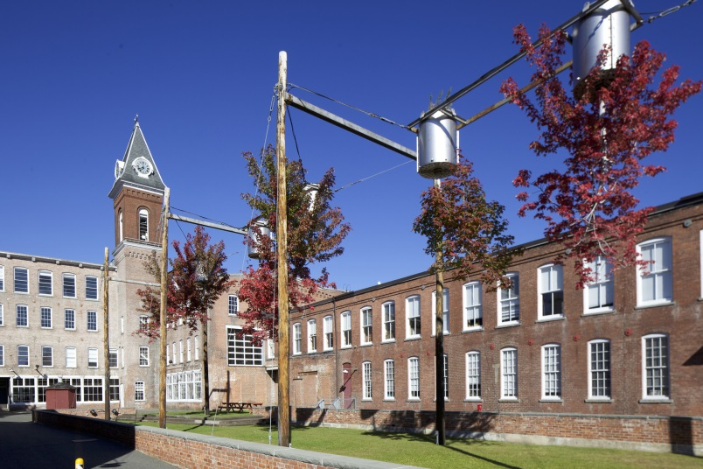
North Adams, Massachusetts — MASS MoCA announces a $500,000 grant from The Andrew W. Mellon Foundation to support the creation and presentation of new work at the intersection of the visual and performing arts through its Confluence Artist Residencies. Leveraging the museum’s existing technical and production residency program, Made at MASS MoCA, the Mellon initiative deepens collaborative relationships and specifically targets projects that cross over between the fields of the performing and visual arts. It also supports training and experiential-based education through the creation of a two-year Confluence Internship program.

Confluence Artist Residencies increase MASS MoCA’s services, facilities, expertise, and audience interactions with artists whose works do not fit easily into a narrow definition of performing or visual arts. “This kind of collaboration is often the most interesting, but also the most difficult to achieve because of scheduling difficulties and complicated technical needs. Work that ‘crosses over’ between theatrical practice and gallery installation draws on all our institutional resources. It is challenging work, risky, essential, and at the heart of MASS MoCA’s mission to help make and show art of unusual ambition and scale,” says Joseph Thompson, director, MASS MoCA.
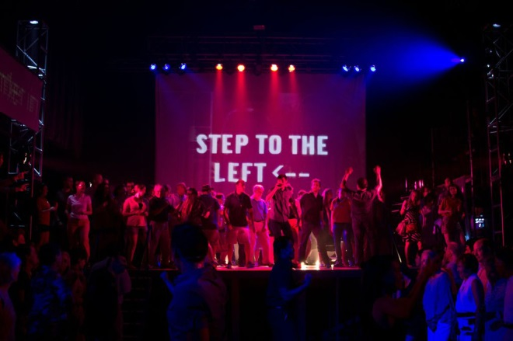
The museum has become a sought-after, distinctive residency option for artists. MASS MoCA’s respect for artists and the artistic process, its theatrical and sculptural production capabilities, and its creative environment set it apart from many other residency options. “MASS MoCA starts by saying ‘yes’ to our artists and tailors residencies to what the artist needs,” says Sue Killam, MASS MoCA’s managing director of performing arts. “This approach is magnified ten-fold by the fact that our rehearsal, performance, and studio spaces are valued by artists for their generous dimensions and quality, and also for their flexibility. For example, both of our theater spaces and the audience configurations can be customized; if an artist is preparing a new work for a premiere at the Brooklyn Academy of Music (BAM), for example, MASS MoCA can nearly replicate that space here.” Artists feel comfortable experimenting in a shared production and/or fabrication process with MASS MoCA staff without fear of a high-pressure premiere schedule.
Here Lies Love, 2012, a work-in-progress by David Byrne, Alex Timbers, and Annie-B Parsons.

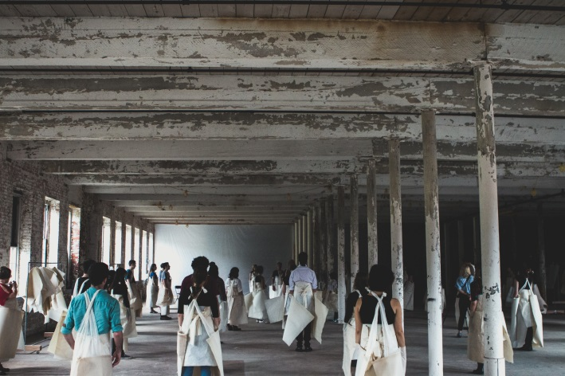
For the visual arts, wood and metal-working shops, in addition to long- and short-term artist studio space, are available at flexible hours. The museum has excellent welders, riggers, and carpenters on its art fabrication crews. Curator Susan Cross points to a recent collaboration between artist Ann Hamilton and the Bang on a Can Summer Music Festival as an example of the museum’s support of artists whose projects reach across disciplines. “The incredibly lively musical performance — incorporating instruments and wearable works on paper designed by Hamilton with music and choreography by Bang on a Can — demonstrates the creative possibilities for the kind of cooperation and combined programming that will be fostered by the Mellon.”
Bang on a Can faculty and fellows perform Ann Hamilton’s Paper Chorus in MASS MoCA’s galleries, 2014.
The Confluence Artist Residency program hosts two residencies per year dedicated to the creation of new interdisciplinary work. The chosen projects require, on average, three-week residencies and involve multiple artists and their respective support staff. Residency artists and art collectives are selected by the MASS MoCA curatorial staff for their potential to draw on the full range of institutional resources.

The first full-scale Confluence Artist Residency will occur between February 20, 2015, and March 8, 2015, when dancer/choreographer Lucinda Childs, architect/artist Frank Gehry, and composer John Adams are in residence at MASS MoCA to re-conceive Available Light. In 1983, Available Light was the first in a series of projects commissioned by the Museum of Contemporary Art in Los Angeles (LA MOCA) that gathered teams of artists to develop collaborative performance pieces. Available Light represents the first and only time that Childs, Gehry, and Adams worked together. The trio began collaborating in 1981; after two years, they added to their team theatrical lighting designer Beverly Emmons and noted fashion designer Ronaldus Shamask. Together, the group created an hour-long, multi-layered work comprised of 11 dancers, original music for synthesizers, a set with industrial platforms and chain link fencing material, pod-like costumes, and light. Available Light combines dance, music, and visual art (architecture, design, and lighting); in re-envisioning the work, the artists will update and refresh the original show, configuring it for travel to other venues, including the Brooklyn Academy of Music in 2015.

Confluence Internship
Over the course of the three-year Mellon-funded project, MASS MoCA will offer two specialized Confluence Internships for those interested in pursuing a career at the junction of the visual and performing arts. These interns will work closely with the curatorial and performing arts departments, researching, writing about, and assisting on all aspects of realizing Confluence Artist Residencies. Modeled after MASS MoCA’s highly successful visual arts internship program with the Graduate Program in the History of Art, a joint program of Williams College and the Clark Art Institute, Confluence interns are trained and mentored in all areas of production. But with its 48-month time commitment, the Confluence Internships will be distinct from MASS MoCA’s long-established intern education program, which provides housing and stipends to 40 interns each year.

About MASS MoCA
MASS MoCA is one of the world's liveliest (and largest) centers for making and enjoying today's most important art, music, dance, theater, film, and video. Hundreds of works of visual and performing art have been created on its 19th-century factory campus during fabrication and rehearsal residencies, making MASS MoCA among the most productive sites in the country for the creation and presentation of new art. More platform than box, MASS MoCA strives to bring to its audiences art experiences that are fresh, engaging, and transformative.

MASS MoCA's galleries are open 11am to 5pm every day except Tuesdays. The Hall Art Foundation’s Anselm Kiefer exhibition is open seasonally, through November 30. Gallery admission is $18 for adults, $16 for veterans and seniors, $12 for students, $8 for children 6 to 16, and free for children 5 and under. Members are admitted free year-round. For additional information, call 413.662.2111 x1 or visit massmoca.org.

Contact
Jodi Joseph, Director of Communications
413.664.4481 x8113
jjoseph@massmoca.org

